# Homework Week 10

## Katherine Hawkins – 31561764

### Lab: Varun Mathur Monday 12pm

## Task 1 – Interactive Chart:

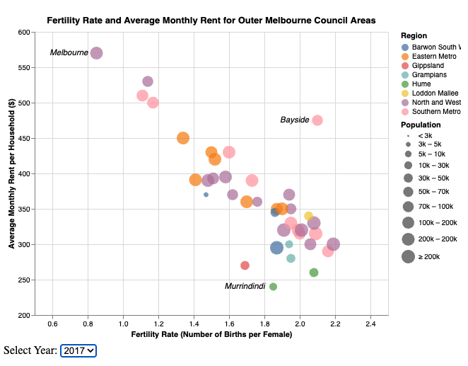

## Task 2 – HTML Page:

URL of GitHub webpage:

<https://katherinehawkins.github.io/Homework-Week-10/>

#### Domain of Data Visualisation 2

* Data Visualisation 2 explores the trends in fertility rates for outer Melbourne, with regards to the increases in the cost of living.

#### Datasets Used

* Census data by region
  + URL: <https://www.abs.gov.au/methodologies/data-region-methodology/2011-23#:~:text=Download%20XLSX,%5B25.27%20MB%5D>
  + Author: Australian Bureau of Statistics
  + Uses the local council areas in Table 2, under the attribute Label (Qualitative).
  + Uses the Year attribute from Table 2.
  + Uses the Estimated resident population from Table 2 (Quantitative)
  + Uses Total fertility rate from Table 2 (Quantitative, rate data)
* Quarterly Median Rents by LGA
  + URL: <https://www.dffh.vic.gov.au/quarterly-median-rent-local-government-area-march-quarter-2024-excel>
  + Author: Homes Victoria
  + Uses the median rental house prices for all property types for the years 2017-2021 (Quantitative)

#### Why a Bubble Chart is Used

* A bubble chart was chosen because it allows for multiple variables to be shown in a concise way. For example, the sizes of the populations are depicted through the mark size, the region is shown by colour, the positioning on the x-axis demonstrates fertility rate and the position on the y-axis shows median rental prices. This type of chart can demonstrate many variables at once without becoming cluttered and confusing for the user, hence why it was chosen to convey this data.